**Assignment 1**

**Topic = S3**

**1: Create an S3 bucket**

**2 : Upload 2 object**

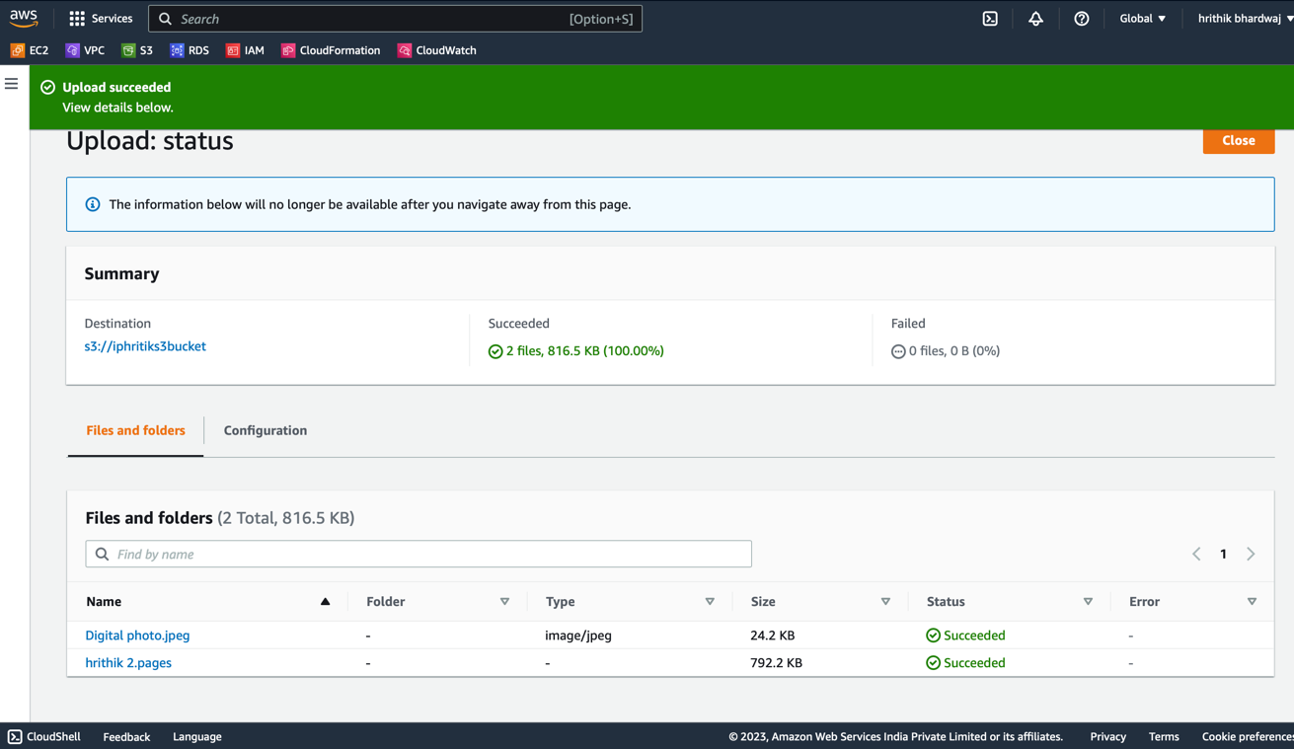

**Assignment 2**

1. **: Enable versioning for the bucket created in task 1**

1. **: Now upload the same 2 objects and verify if the versioning works**

**Assignment 3**

1. **: Now, make the same bucket to be Static website host and upload an index.html and error.html page**

**Index.html**

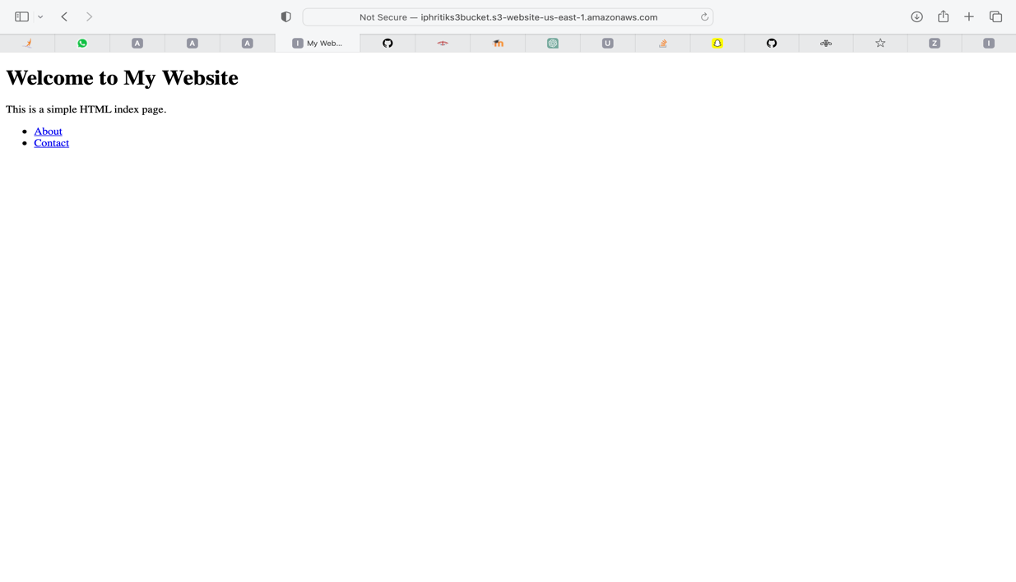

**Error page**

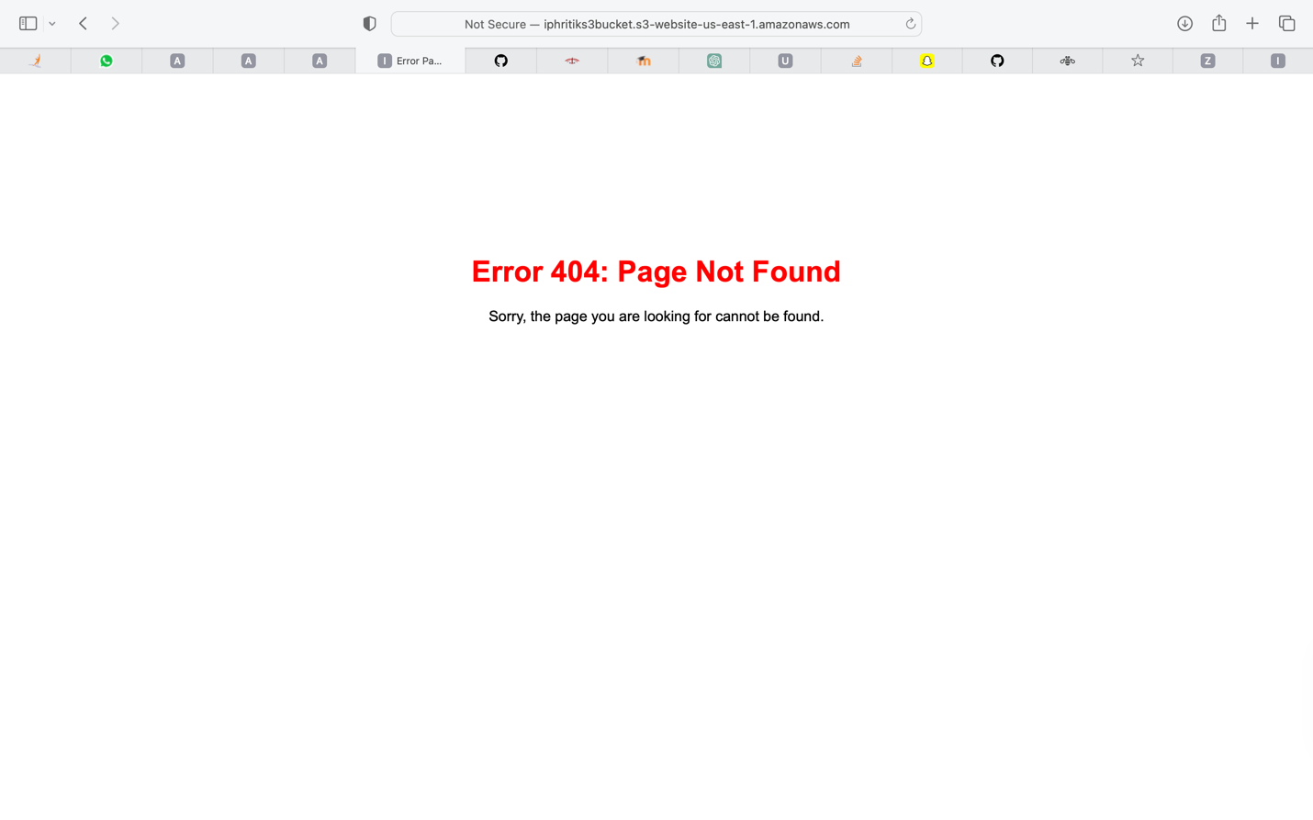

**2: Also, add a lifecycle rule for the bucket:**

* 1. **Transition from Standard to Standard-IA in 60 days**
  2. **Expiration in 200 days**

